Normalisation – in database, is the process of structuring a relational database to minimise data redundancies and improve data integrity.

A database is in its First Normal Form 1NF when:

* All of the key attributes are defined
* There are no repeating groups in the table
* All attributes are dependent on the primary key

A database is in its Second Normal Form 2NF when:

* Including the requirements of the 1NF
* It has no partial dependencies; that is no attribute dependent on only a portion of the primary key.

A database is in its Third Normal Form 3NF when:

* Including the requirements of the 2NF
* It contains no transitive dependencies

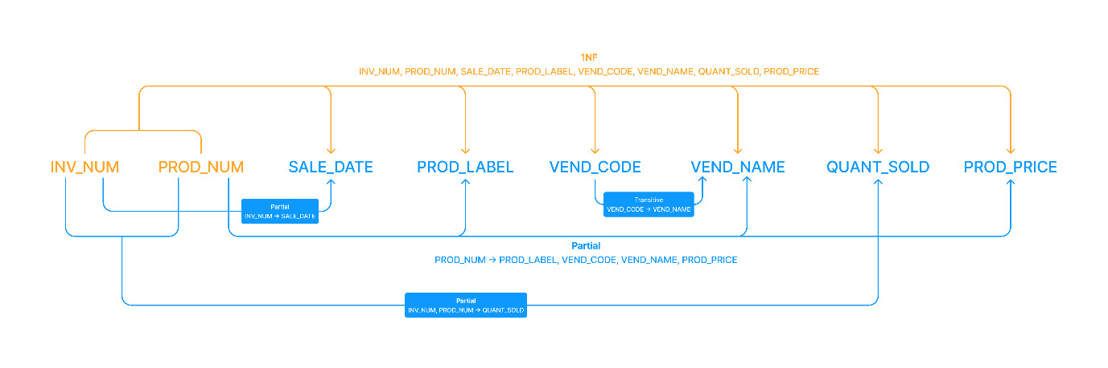

Figure : Initial Database – Dependency Diagram

**Primary Keys:**

INV_NUM

PROD_NUM

INV_NUM_PROD_NUM

**Full Dependencies:**

INV_NUM_PROD_NUM **→** SALE_DATE, PROD_LABEL, VEND_CODE, VEND_NAME, QUANT_SOLD, PROD_PRICE

**Partial Dependencies:**

INV_NUM **→** SALE_DATE

PROD_NUM **→** PROD_LABEL, VEND_CODE, VEND_NAME, PROD_PRICE

INV_NUM_PROD_NUM **→** QUANT_SOLD

**Transitive Dependencies:**

VEND_CODE **→** VEND_NAME

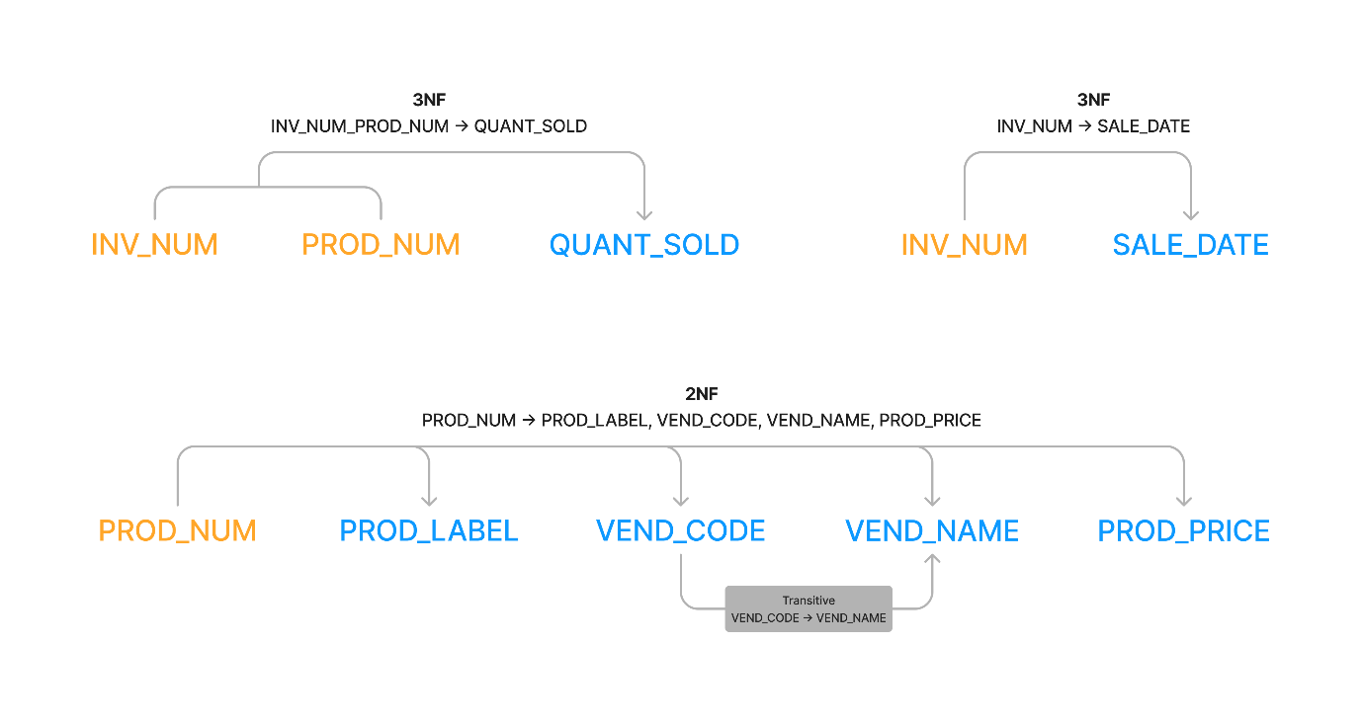

Figure : Removing Partial Dependencies

**2 off Third Normal Form Tables:**

INV_NUM_PROD_NUM **→** QUANT_SOLD

INV_NUM **→** SALE_DATE

**1 off Second Normal Form Table:**

PROD_NUM **→** PROD_LABEL, VEND_CODE, VEND_NAME, PROD_PRICE

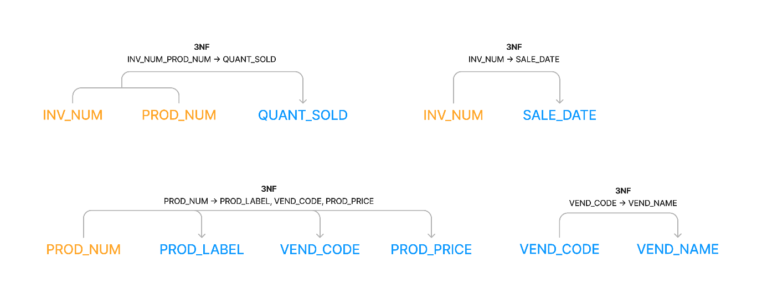

Figure : Removing Transitive Dependencies

**4 off Third Normal Form Tables:**

INV_NUM_PROD_NUM **→** QUANT_SOLD

INV_NUM **→** SALE_DATE

PROD_NUM **→** PROD_LABEL, VEND_CODE, VEND_NAME, PROD_PRICE

VEND_CODE **→** VEND_NAME